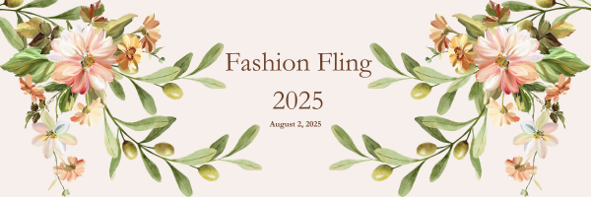

March 7, 2025

Dear Friend,

Planning has begun for the 10th Annual Fashion Fling to be held on Saturday, August 2, 2025, in the Peck Barn at The Compound in Round Top. We are excited to get together again! Hosted by United Women of Hospice, proceeds from this Luncheon, Style Show, and Silent Auction benefit the patients and families served by Hospice Brazos Valley.

Hospice Brazos Valley serves Fayette and surrounding counties and is the only non-profit hospice in the area. Our offices in Bryan, Brenham, and La Grange provide services to all, regardless of the ability to pay. The Medicare and insurance reimbursement we receive does not cover the comprehensive hospice care and bereavement services that Hospice Brazos Valley provides to our patients and their families. Currently, the difference between what we receive in reimbursement and our expense is $16.00 per patient per day. In 2024, we provided 46,847 days of care, of which 1,572 were unfunded (uninsured). This is why we need you to partner with Hospice Brazos Valley to raise vital funds for our mission of providing end-of-life services to patients and their families.

Hosting a table at Fashion Fling, making a monetary donation as a sponsor of the event, or providing an auction item helps our team care for individuals suffering from terminal or chronic illnesses for years to come. Every donation makes a difference in Fayette County and the rest of our 17-county service area.

Enclosed you will find a Table Hostess/Sponsor/Donor form for this event. There is also an online form available at http://weblink.donorperfect.com/fashionfling2025 for table registrations, sponsorship, or silent auction donations. For questions or more information regarding Hospice Brazos Valley or the Fashion Fling, please email events@hospicebv.org, visit hospicebv.org, or contact Coleen Broussard at 979.821.2266.

Caring together,



Lisa McNair

President/CEO

Hospice Brazos Valley